Two Point Perspective Study Guide
Two-point perspective is a drawing method that uses two vanishing points on the horizon line to create the illusion of three-dimensional depth and space on a two-dimensional surface. It is primarily used to depict objects, such as buildings or boxes, viewed from an angle (corner-on) rather than head-on. This technique is particularly effective for drawing objects or scenes where the viewer sees two sides of an object, such as corners of buildings or structures.

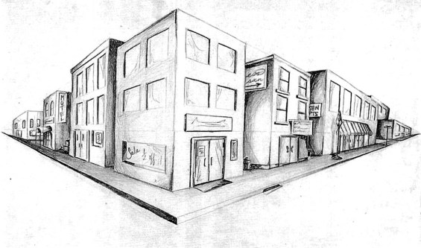

Key Principles:
- Two Vanishing Points: All horizontal lines (edges) recede toward or converge at one of two vanishing points located on the far left and right sides of the horizon line.
- Verticals Remain Vertical: Unlike horizontal lines, vertical lines (up-and-down edges) stay perfectly parallel to each other and perpendicular to the ground.
- Corner-First View: The nearest vertical edge of the object faces the viewer directly.
- Vanishing Points Position: The vanishing points are typically placed far apart on the horizon line to avoid extreme distortion.

Simple Steps to Draw:
- Draw a Horizon Line: Draw a straight horizontal line to represent eye level.
- Place Vanishing Points: Place two dots (VP1 and VP2) at opposite ends of this line.
- Draw a Vertical Line: Draw one vertical line between the two points to represent the closest corner of your object (e.g., a building).
- Connect to Vanishing Points: Draw lines from the top and bottom of your vertical line to both vanishing points.
- Define Width and Depth: Add two more vertical lines to represent the left and right corners of your object.
- Add Details: Erase excess lines to finalize the 3D shape. If you are drawing a building, the top and bottom edges of doors, windows, and trim must recede toward the vanishing point. The same is true for lettering on signs.

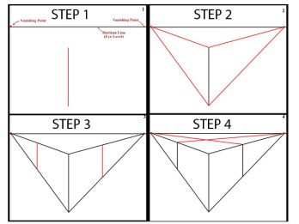
This is a video explaining and demonstrating the basics of two-point perspective:
What is 2-point perspective? Everything you need to know
https://safeshare.tv/x/2o4dJ28Z2QU

